**Employee Management System**

Frontend : Reactjs

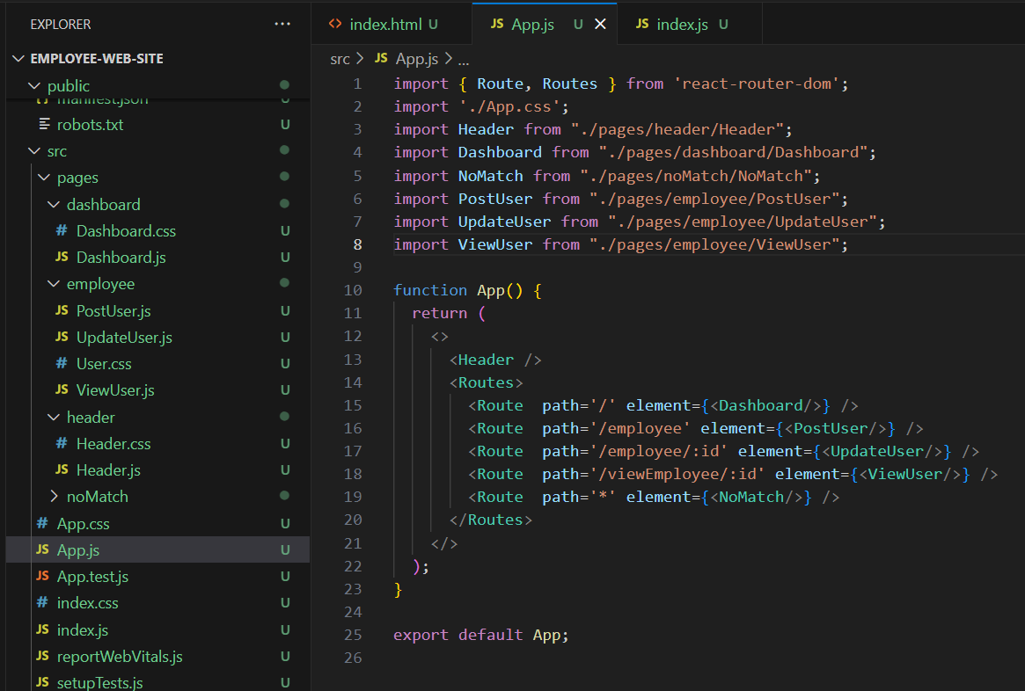

Backend : Springboot

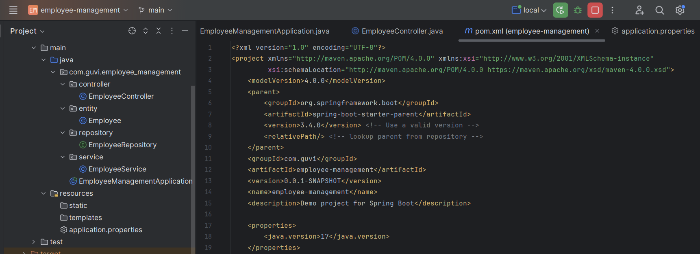

Database : Mysql

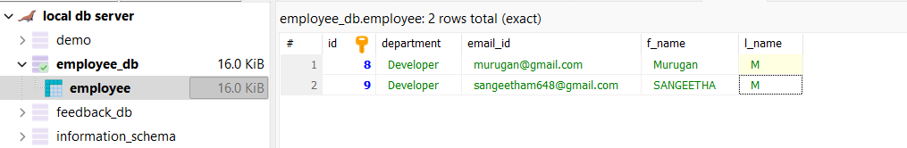

Entity data

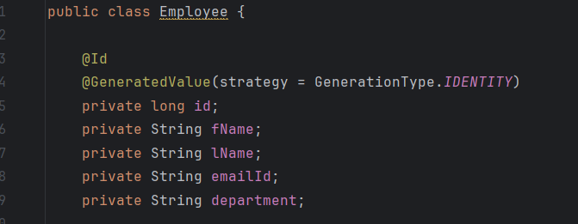

API Endpoints:

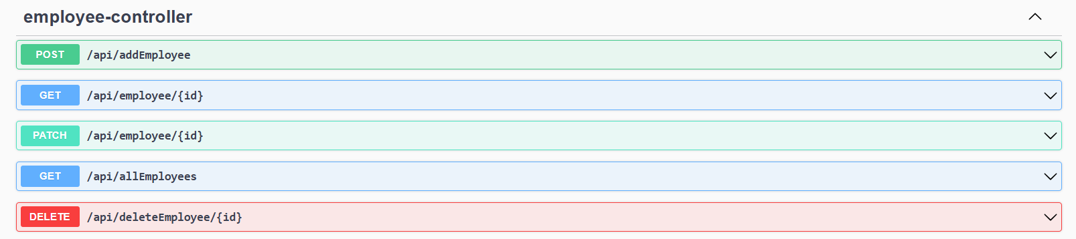

Delete API:

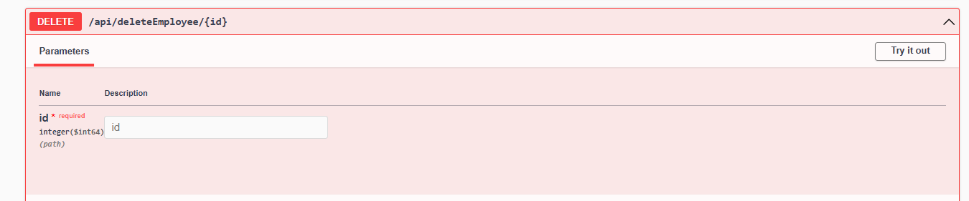

Get API:

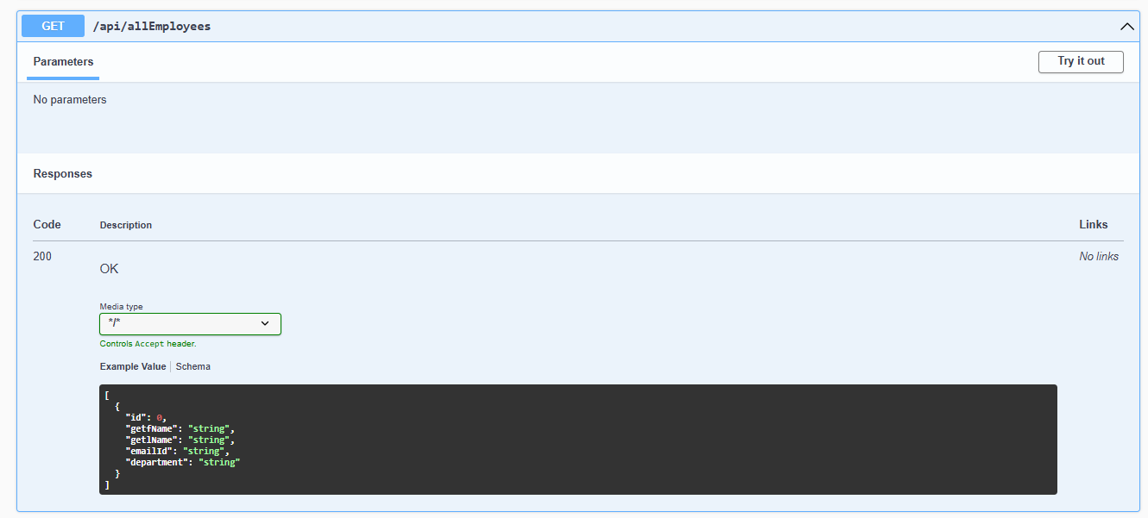

Post API

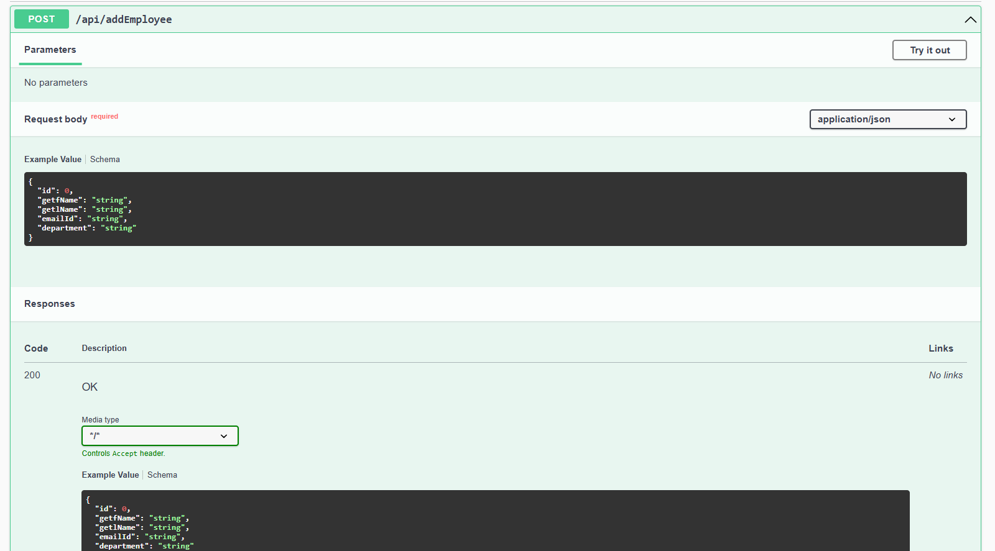

Get API with id

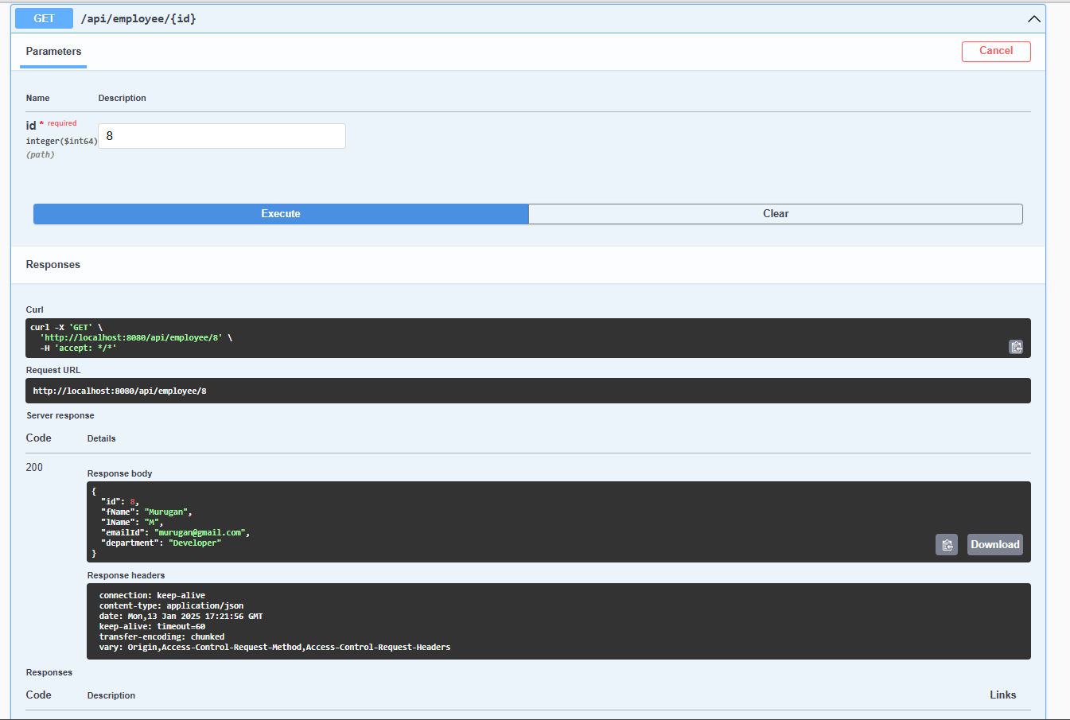

Patch API

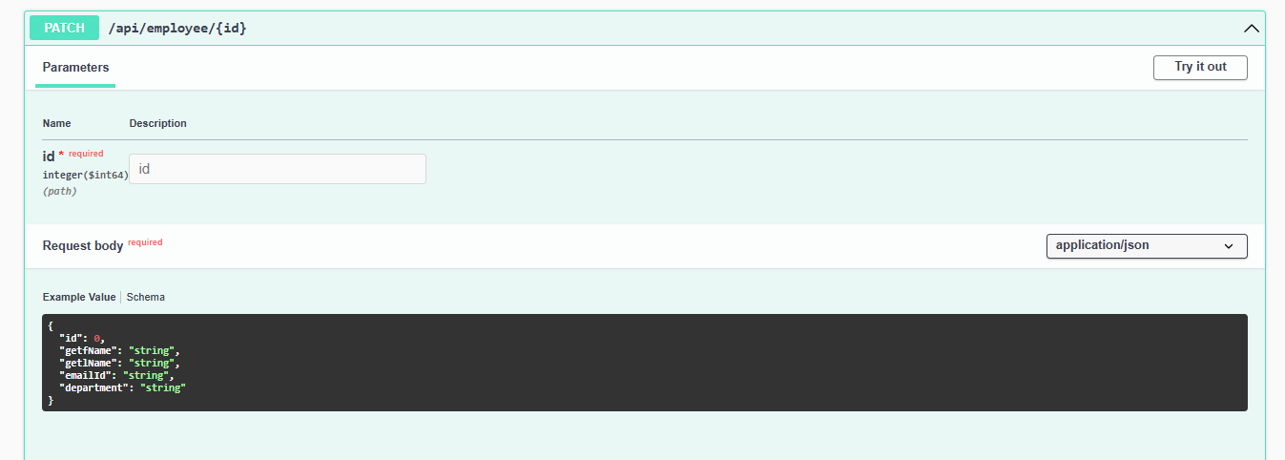

video link – <https://drive.google.com/file/d/1k3y5_2xFOI0UdzfCRzbR32w703CxnhkS/view?usp=drive_link>